1. Summarize chapters 1 in the text book.

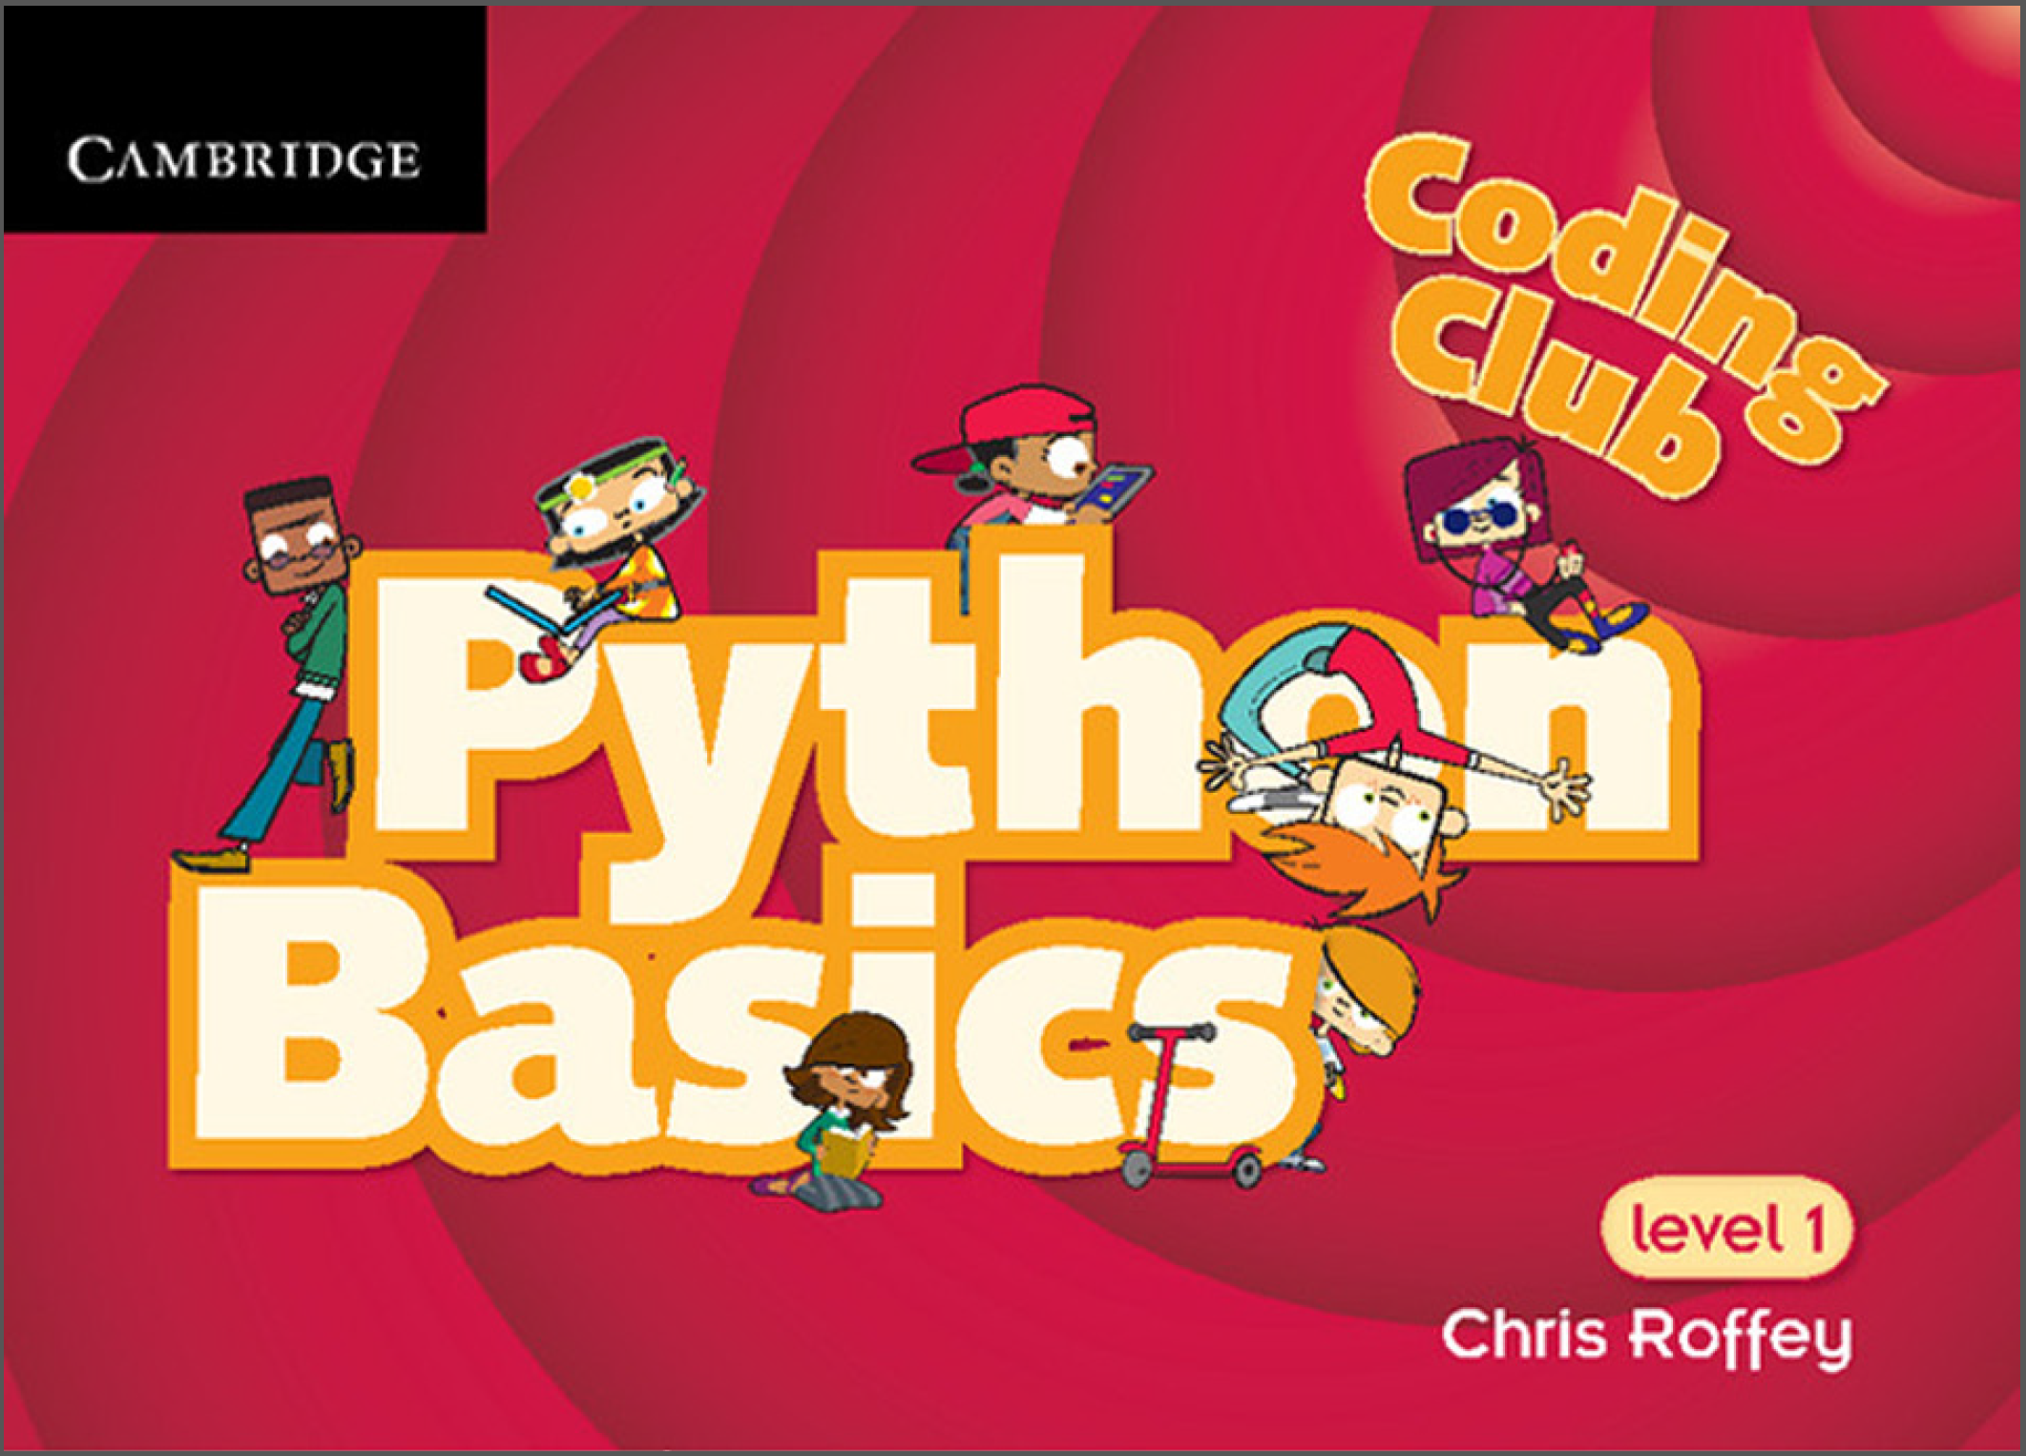

1. Try to install the Python based on the P_L_02_Fin.pptx file.